DAY 1 OF MY Phishing project
Today I am building the structure of my project, the project is a created a phishing awareness detection tool kit that will analyse emails for phishing indicators, highlight the suspicious elements for users, and also provide further educational insight on phishing emails and improve the users' understanding of phishing emails, to try to tackle the increasing number of successful phishing attacks that organisations and users face on a daily basis.
I will be doing this small report on my project every day I’ll spend 2 hours on it report my findings and screenshots to show myself of my progress as I keep going.
First thing I did was download my tow datasets from kagle, a set of phishing Site URls and a set of Phishing emails, this set will be enough to test my machine on the coming days of my project.
I picked random forest because it fits well as it naturally handles the kind of messy, mixed-signal data that phishing emails and URLs produce. Thus, it can give me high accuracy, strong generalisation, and clear explanations which align perfectly with my project aims.
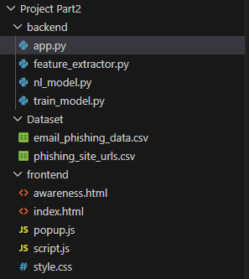
Figure 1 Project structure
This is the structure I created for myself, I find it easier with simple structure and this is the best one I’ve found myself working with after multiple tries of creating a phishing project.

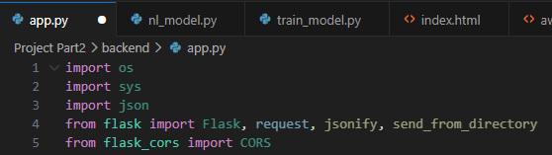
Figure 2 importing modules to build a web application
Here, you can see all the imports I’m using to build my web application. The Os and sys modules are there to provide access to operating systems and system-specific parameters, while json helps with handling the JSON data, and then obviously the flask module is used to create the web server and handle HTTP requests, and flask_cors (after being imported) will permit my application to handle cross-origin Resource sharing (CORS) this will allow for my backend coding to communicate securely with my front end coding applications which will be hosted on different domains.
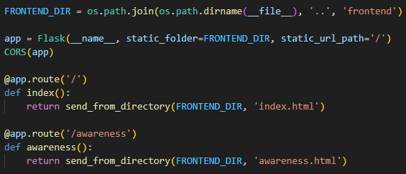
Figure 3 FRONTEND IMPLEMENTATION
These lines that I’ve implemented configure my Flask backend to serve my frontend web files and allow communication between the front end and backend. By setting the FRONTEND_DIR variable. This specifies the location of my frontend assets. The Flask app then sets up to serve static files from

